**Musa Haji  
230701391  
EX NO. 11:  
Software Testing in Microsoft Azure**

Aim

To perform automated and manual software testing using Microsoft Azure tools and services to ensure the quality, performance, and security of applications deployed in the cloud environment.

Procedure

1.Set Up Azure Environment

Sign in to the Azure Portal.

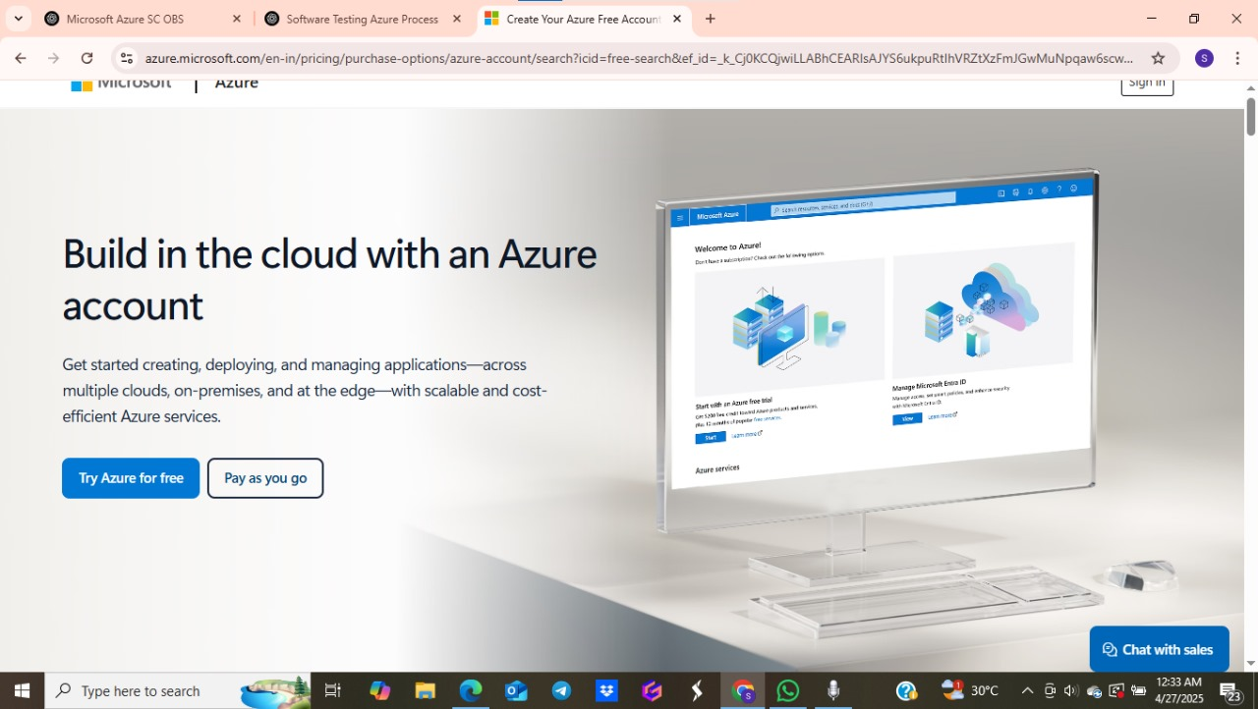

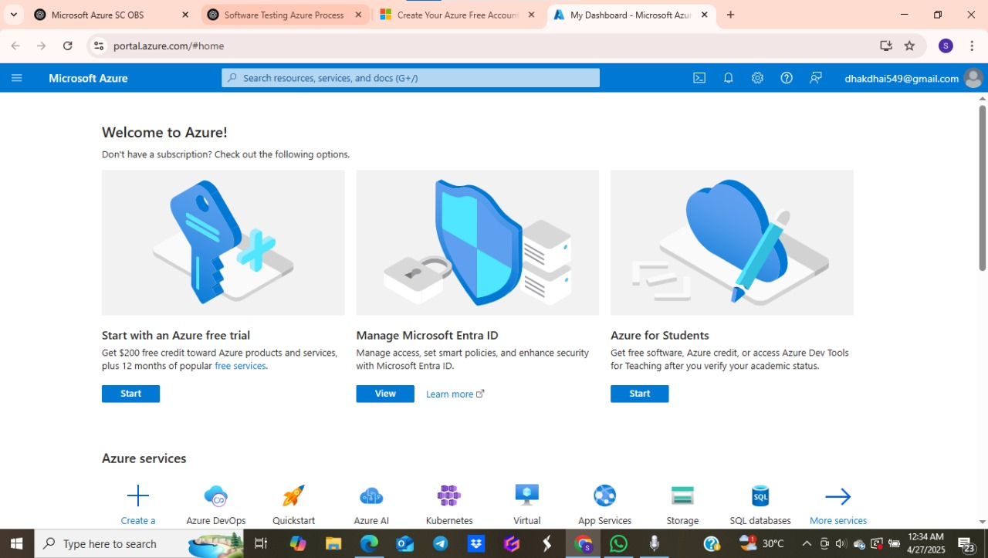

Create necessary resources (App Services, VMs, or Azure Kubernetes Service) to host the application to be tested.

2.Prepare Application for Testing

Deploy the application to Azure.

Ensure that application endpoints are accessible and configure Azure DevOps or GitHub repositories for CI/CD integration.

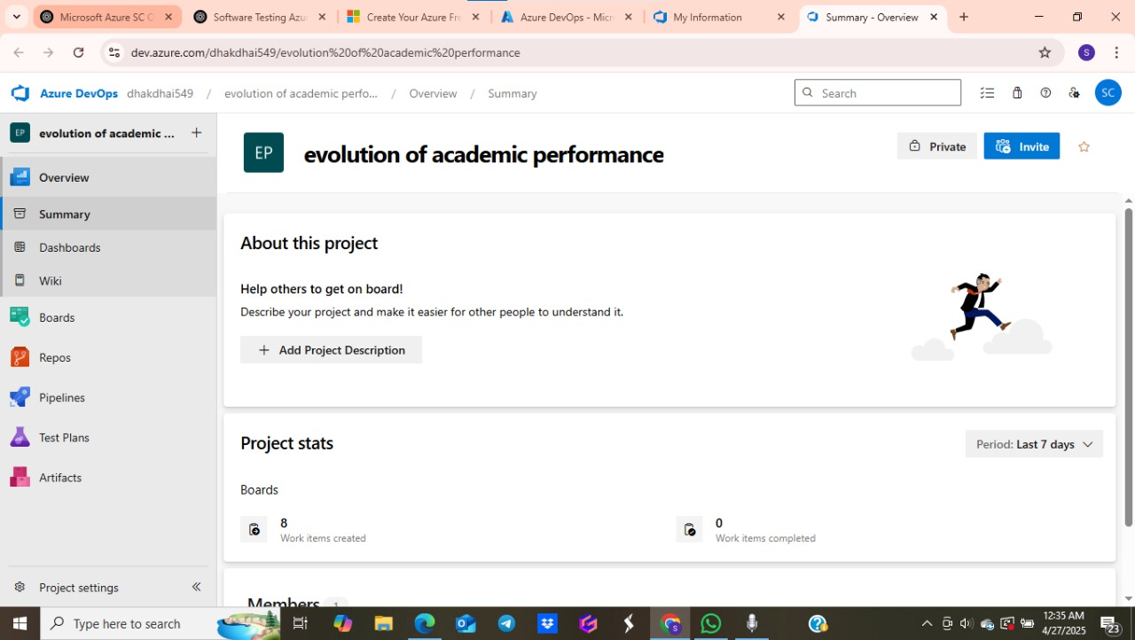

3.Select Testing Tools and Services

Use Azure DevTest Labs to create isolated test environments.

Set up Azure Load Testing for performance and stress tests.

Use Azure Application Insights to monitor real-time application performance.

Integrate Azure Test Plans (from Azure DevOps) for manual and exploratory testing.

Optionally, use third-party testing tools like Selenium, Postman, or JMeter, integrated with Azure Pipelines.

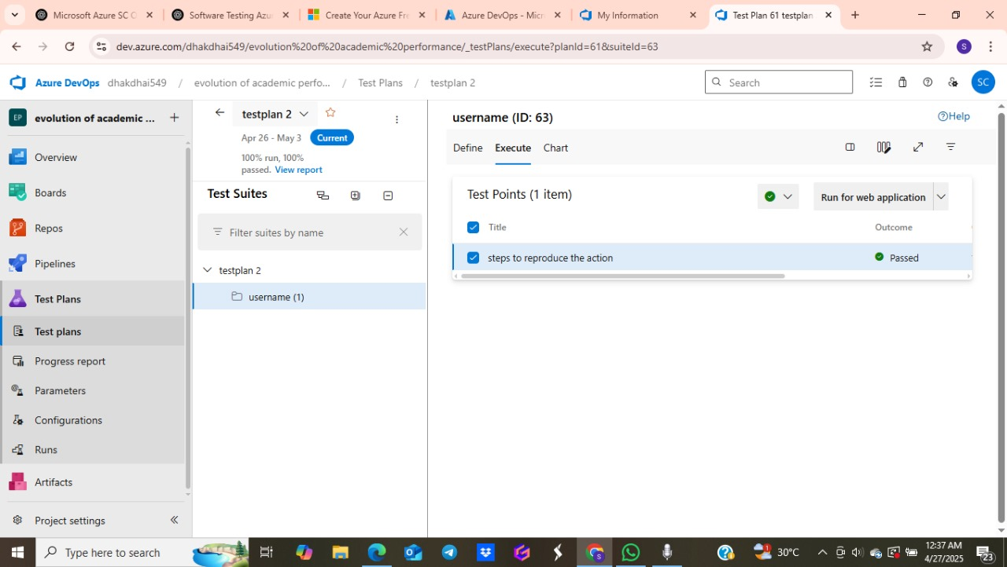

4.Create Test Plans and Cases

In Azure Test Plans, define test suites (manual/automated).

Write detailed test cases covering functionality, usability, security, and performance.

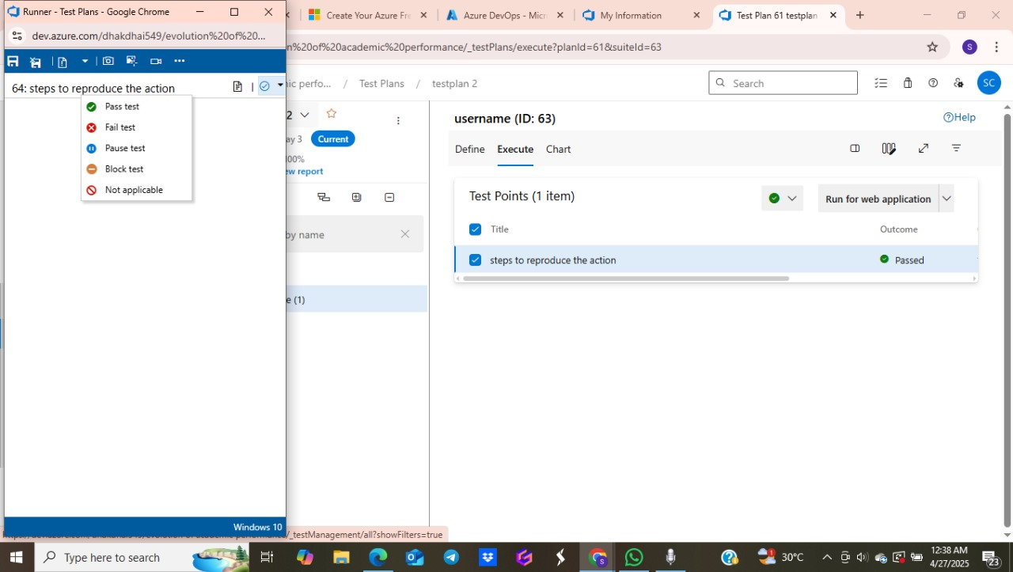

5.Run Tests

Perform manual testing using Azure Test Plans dashboards.

Trigger automated tests during CI/CD pipelines using Azure Pipelines.

Conduct load tests via Azure Load Testing.

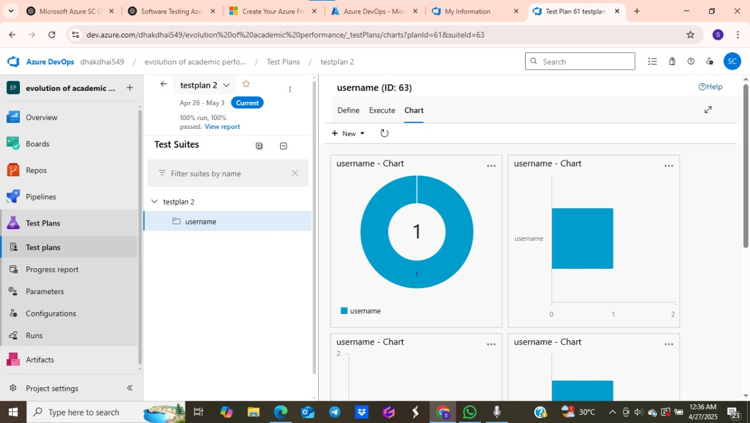

6.Monitor and Analyze Results

Analyze logs, performance metrics, and test reports from Azure Monitor and Application Insights.

Track defects using Azure Boards.

Generate testing metrics such as pass percentage, failed test cases, and performance degradation.

Report Findings

Prepare a detailed test report summarizing all tests performed, outcomes, bugs found, and overall application health.  
**Flow chart Diagram**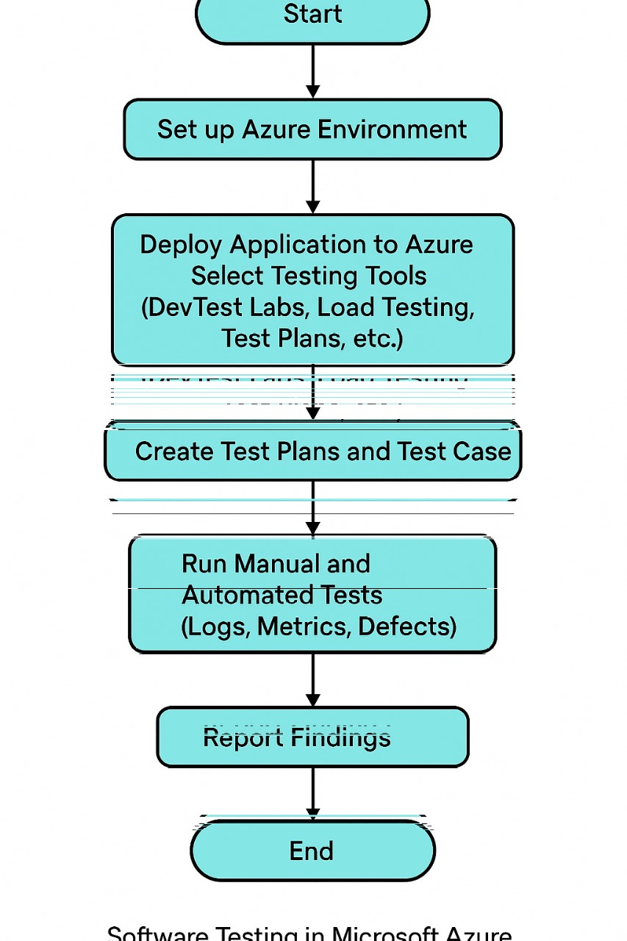

Result

By following the above procedure, the application is thoroughly tested in Microsoft Azure for functionality, performance, and security. Any bugs, performance issues, or potential security risks are identified early, ensuring the application meets the required quality standards before deployment to production.